**Software Requirements and Design Document**

**For**

**Group 27**

Version 2.0

**Authors**:

Ian Estevez

Jack Throdahl

William Hudmon

# Overview (5 points)

GrouPay is a web application designed to facilitate users in reconciling collective debts, by allowing individuals to join billing groups, in which they can independently contribute to bills owed by themselves and their peers within the same billing group. Users must first make accounts to find the other users with which to join the same billing group, set up by a third party such as a landlord (or property manager, company, etc.), after which they can split bills, such as rent or utilities evenly, and/or distribute percentages of the balance due however they decide. This is done using a MySQL database and using Python with Flask to connect to a web app and read the database.

Functional Requirements (10 points)

1. Users should be able to register to an account and create a unique username, enter their first and last name and a password. This is of high priority
2. Using their username and password they can log into an account and search for users, add them, and invite them to a billing group. This is of high priority
3. Users can join billing groups when invited or create one, and make collective payments to a bill. This is of high priority
4. Users can also communicate with the creator of the group to change the distribution of the balance. This is of high priority.
5. Companies should be able to make an account similarly with company name and be able to make multiple billing groups. This is of medium priority
6. Companies should be able to delegate percentages of shared expenses of each billing group to the users of that group. This is of medium priority
7. Companies can add or remove any user from a billing group they created. This is of medium priority.
8. Users should be able to send a friend request to any user they search for. They will become friends with the other user once the other user accepts the friend request. This is of high priority
9. Users should be able to view their friends list and message their friends on the friend’s tab of the website. This is of medium priority

# Non-functional Requirements (10 points)

* The database should be distributed and be able to be accessed from anywhere.
* The site should be secure such that no user can read data from another user.
* The groups page should have a chart displaying how much of the bill is left to be paid.

# Use Case Diagram (10 points)

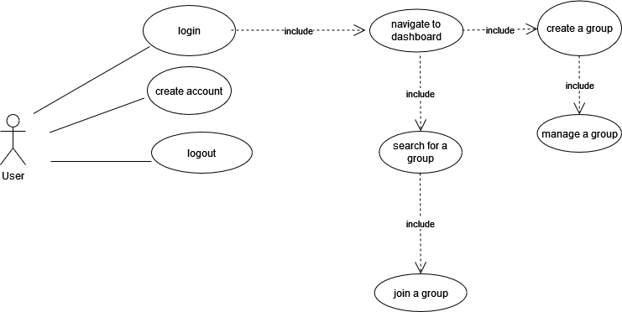

Users can search for a group and join that group in the group search tab

Users should be able to create an account, login, and logout from the home page

Users can create and manage a group from their dashboard

# Class Diagram and/or Sequence Diagrams (15 points)

**6. Operating Environment (5 points)**

The software is supposed to be run on Windows 10 or 11 using a PC but can be ran on a Windows laptop or Ubuntu 22.04 LTS.

**7. Assumptions and Dependencies (5 points)**We are assuming that we will be able to fully distribute the project on a personal computer which may not be possible without a static ip address. This may lead to the project not being fully distributed since a hosting provider would be needed.